

T700**(E)**(A1)T

**NATIONAL CERTIFICATE**

# FITTING AND MACHINING THEORY N2

(11022032)

**1 August 2019 (X-Paper)**

**09:00–12:00**

**Calculators may be used.**

**This question paper consists of 11 pages and 1 formula sheet.**

Please turn over

-2-

## DEPARTMENT OF HIGHER EDUCATION AND TRAINING

**REPUBLIC OF SOUTH AFRICA**

NATIONAL CERTIFICATE

FITTING AND MACHINING THEORY N2

TIME: 3 HOURS

MARKS: 100

**NOTE:** If you answer more than the required number of questions only the required number will be marked. ALL work you do NOT want to be marked must be clearly crossed out.

### INSTRUCTIONS AND INFORMATION

1. Answer ALL the questions in SECTION A, except for QUESTION 1 where either QUESTION 1.1 or QUESTION 1.2 must be answered.

1. Answer any TWO questions in SECTION B.

1. Read ALL the questions carefully.

1. Number the answers according to the numbering system used in this question paper.

1. Write neatly and legibly.

Please turn over

**SECTION A**

### QUESTION 1: OCCUPATIONAL SAFETY (Answer only QUESTION 1.1 or QUESTION 1.2.)

1.1 Choose a term from COLUMN B that matches a description in COLUMN A. Write only the letter (A–F) next to the question number (1.1.1–1.1.5) in the

ANSWER BOOK.

|  |  |  |
| --- | --- | --- |
|  | **COLUMN A** | **COLUMN B** |
| 1.1.1        1.1.2      1.1.3      1.1.4      1.1.5 | Fixed in position and adjusted to within 3 mm of the surface of the grinding wheel    Machine guard used for shafts, pulleys and gears    Outside diameter not less than one third of grinding wheel diameter    Where to store compressed gas cylinders    Machine guard covering circular saw blades, guillotine knives and punch press dies | 1. metal flange      1. ventilated area      1. point-of-operation guard      1. work rest      1. transmission guard      1. concrete store |

(5 × 1)

### OR

1.2 Choose a word from COLUMN B that matches a description in COLUMN A. Write only the letter (A–F) next to the question number (1.2.1–1.2.5) in the

ANSWER BOOK.

|  |  |  |
| --- | --- | --- |
|  | **COLUMN A** | **COLUMN B** |
| 1.2.1      1.2.2      1.2.3      1.2.4    1.2.5 | Term used to describe a mine that has  flammable gases    Person of authority who appoints drivers of self-propelled mobile machines    Never to be stored or left in the  underground workings of a mine    Must be renewed every 3 years    Person of authority who consents to  disturbing place of accident | 1. first aid certificates      1. calcium carbide      1. regional director      1. manager      1. boilers      1. fiery |

(5 × 1) **[5]**

### QUESTION 2: COUPLINGS

2.1 Name the group of the coupling that would be used in the following cases:

2.1.1 Where accurate alignment of the connecting shafts is guaranteed.

2.1.2 Where there is a small degree of misalignment of the connecting shafts.

1. × 1) (2)

* 1. FIGURE 1 shows a diagram of a coupling.

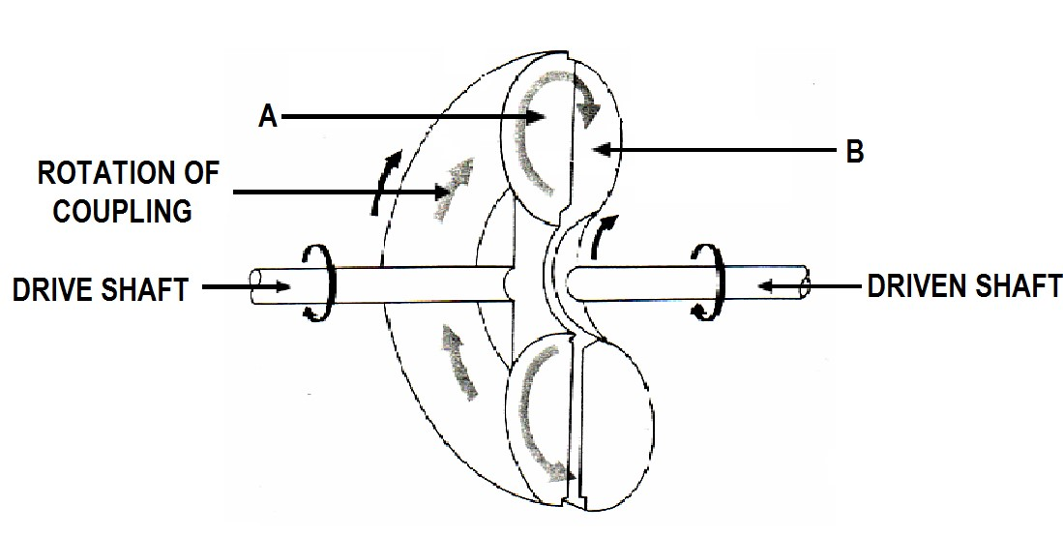

**FIGURE 1**

* + 1. Name the coupling shown in FIGURE 1. (1)

* + 1. Name the group to which this coupling belongs. (1)
    2. Name parts A and B by writing the answer next to the letter (A–B)

in the ANSWER BOOK. (2)

**[6]**

### QUESTION 3: LIMITS AND FITS

A shaft and bush have to be machined according to the dimensions in FIGURE 2 below.



∅40

+

0

.

035

mm

−0

.

010

mm



∅40

+

0

.

030

mm

−0

.

020

mm

### FIGURE 2

Determine each of the following:

3.1 High limit of shaft (1)

3.2 High limit of bush (1)

3.3 Low limit of shaft (1)

3.4 Maximum allowance of fitted parts (2)

3.5 Minimum allowance of fitted parts (2)

**[7]**

### QUESTION 4: BEARINGS

4.1 State the function of a bearing. (1)

4.2 Name FOUR different types of materials that are used to manufacture *plain*

*bearings.* (4)

**[5]**

### QUESTION 5 : LUBRICATION AND VALVES

5.1 Name THREE lubricating devices associated with gravity feed lubrication. (3)

5.2 Explain the working principle of a *foot valve*. (3)

**[6]**

### QUESTION 6: PACKING, STUFFING BOXES, JOINTS AND WATER PIPE SYSTEMS

6.1 List FOUR factors to consider when choosing jointing materials. (4)

6.2 Why do the gunmetal rings in a steam assembly have a wedge design? (1)

6.3 State FOUR advantages of using plastic piping. (4)

**[9]**

### QUESTION 7: PUMPS

7.1 Name the type of reciprocating pump that are described below:

7.1.1 Has only one inlet and one delivery valve.

7.1.2 Liquid is drawn in and delivered during the same stroke.

7.1.3 The high-pressure seal reciprocates with the piston.

(3 × 1) (3)

7.2 Name THREE types of pumps that are classified as *rotary pumps*. (3)

**[6]**

### QUESTION 8: COMPRESSORS

Name the marked components of the single-stage centrifugal compressor shown in FIGURE 3 by writing the answer next to the letter (A–D) in the ANSWER BOOK.

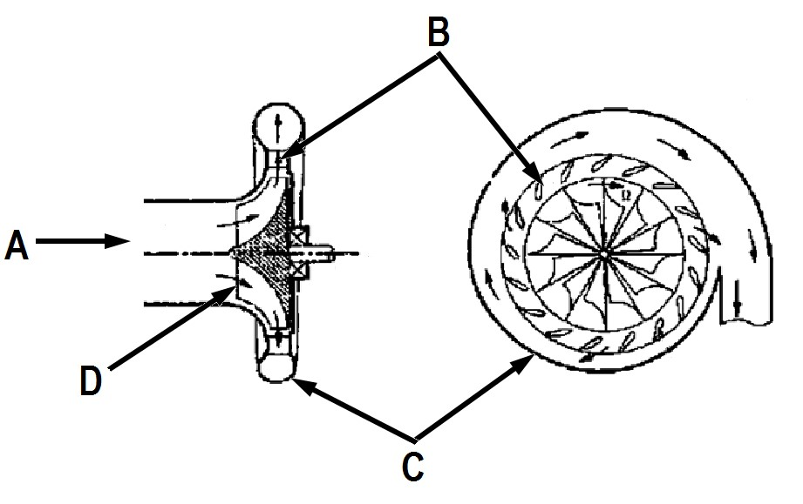

**FIGURE 3** **[4]**

### QUESTION 9: V-BELTS, GEAR DRIVES, CHAIN DRIVES AND REDUCTION GEARBOXES

9.1 Name TWO methods that are used to couple two shafts that are parallel with

each other. (2)

9.2 What should the deflection be if a belt of a V-belt drive is to have the correct tension? (1)

9.3 State THREE uses of gear drives. (3)

9.4 When maintaining chain drives, state the action that should be taken when inspecting the following:

9.4.1 The sprocket bearings. (1)

9.4.2 The sag of the chain. (1)

9.5 Give TWO reasons why it is not possible to drive the rollers of a rolling mill

directly from a motor. (2)

9.6 Name the TWO types of reduction gearboxes used in industry. (2)

**[12]**

**TOTAL SECTION A:**  **60**

**SECTION B**

Answer any TWO of the following questions in SECTION B.

### QUESTION 10: HYDRAULICS AND PNEUMATICS

10.1 State THREE main functions of oil in a hydraulic system. (3)

10.2 Make neat, freehand sketches of the ISO symbols representing each of the following hydraulic components:

10.2.1 Hydraulic pump

10.2.2 Pressure relief valve

10.2.3 Reservoir

(3 × 1) (3)

10.3 State the function of the following hydraulic components:

10.3.1 Hydraulic pump (1)

10.3.2 Pressure relief valve  (1)

10.3.3 Reservoir (1)

10.4 Name the component that is used to generate signals for the purpose of sensing, processing and controlling in a hydraulic circuit. (1)

10.5 Identify each of the following ISO pneumatic symbols:

10.5.1

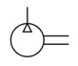

10.5.2

10.5.3

10.5.4

10.5.5

(5 × 1) (5)

10.6 Indicate whether the following statements are TRUE or FALSE. Choose the answer and write only 'True' or 'false' next to the question number (10.6.1–10.6.4) in the ANSWER BOOK.

10.6.1 Hydraulic systems are cheaper to set up than pneumatic systems.

10.6.2 It is important to document all checks and inspections of

compressors in a log book.

10.6.3 Power losses occurring over long distances are a disadvantage in pneumatic systems.

(3 × 1) (3)

10.7 Give TWO reasons for using pneumatic systems in the manufacturing of

chemicals and explosives. (2)

**[20]**

**AND/OR**

### QUESTION 11: CENTRE LATHES

11.1 State TWO uses of lathe steadies. (2)

11.2 Name the steady that you would use in each of the following applications:

11.2.1 To turn a long, small diameter shaft

11.2.2 To support a square bar that must be bored

(2 × 1) (2)

11.3 Define the term *helix angle*. (1)

11.4 A three-start square thread with a 10 mm pitch is to be cut on a centre lathe with a 5 mm pitch lead screw.

Calculate the following if the pitch diameter (mean diameter) of the thread is 155 mm:

**NOTE**: Assume the clearance angle to be 3°.

11.4.1 Helix angle of the thread (3)

11.4.2 Leading angle of the screw cutting tool used (2)

11.4.3 Following angle of the screw cutting tool used (2)

11.5 A steel pin with a diameter of 20 mm is machined on the lathe at a spindle speed of 24 r/sec.

Calculate the cutting speed of the specific metal in metres per minute. (3)

11.6 The time taken to complete a longitudinal cut along a workpiece 700 mm long and rotating at a speed of 130 r/min is 15 minutes.

Calculate the feed of the cutting tool in mm per revolution. (3)

11.7 Name the command types for each of the following CNC functions:

11.7.1 Code commands for the machine to prepare for a specific machine cycle

11.7.2 On-off function of the CNC lathe motor

(2 × 1) (2)

**[20]**

**AND/OR**

Please turn over

### QUESTION 12: MILLING MACHINES AND SURFACE GRINDERS

12.1 State the function of the *sector-arms* on the index plate of the dividing head. (1)

12.2 Distinguish between the Cincinnati index plate and the Brown and Sharp

index plate. (2)

12.3 Name the milling cutter used to produce wide flat surfaces. (1)

12.4 Calculate the required indexing for an angular groove of 42°45' using a Brown

and Sharp dividing head.

|  |  |  |  |  |  |  |
| --- | --- | --- | --- | --- | --- | --- |
|  | **THE BROWN AND SHARP DIVIDING HEAD** | | | | |  |
|  | **NUMBER OF HOLES** | | | | |  |
| Plate 1 | 15 | 16 | 17 | 18 | 19 | 20 |
| Plate 2 | 21 | 23 | 27 | 29 | 31 | 33 |
| Plate 3 | 37 | 39 | 41 | 43 | 47 | 49 |

(7)

12.5 List FOUR reasons for using nicked helical milling cutters.

12.6 Explain the following terms which apply to grinding wheels:

12.6.1 Grit size

12.6.2 Grade of the grinding wheel

12.6.3 Structure of the grinding wheel

12.6.4 Structure number

12.7 State the reason for surface grinding.

(4)

(4 × 1) (4)

(1)

**[20]**

|  |  |
| --- | --- |
| **TOTAL SECTION B:** | **40** |
| **GRAND TOTAL:** | **100** |

Copyright reserved

FITTING AND MACHINING N2

**FITTING AND MACHING THEORY N2**

### FORMULA SHEET

ƒ =ƒ𝑡𝑡 × T × N

𝜋𝜋𝜋𝜋𝜋𝜋

S =

60

𝑆𝑆 = 𝜋𝜋DN

40

N

N

9°

𝜋𝜋 − 𝑑𝑑 𝑙𝑙𝑆𝑆𝑙𝑙𝑙𝑙𝑡𝑡ℎ 𝑜𝑜𝑜𝑜 𝑤𝑤𝑜𝑜𝑜𝑜𝑤𝑤𝑤𝑤𝑤𝑤𝑆𝑆𝑤𝑤𝑆𝑆

𝑆𝑆𝑆𝑆𝑡𝑡 − 𝑜𝑜𝑜𝑜𝑆𝑆𝑜𝑜 = ×

2 𝑙𝑙𝑆𝑆𝑙𝑙𝑙𝑙𝑡𝑡ℎ 𝑜𝑜𝑜𝑜 𝑡𝑡𝑡𝑡𝑤𝑤𝑆𝑆𝑜𝑜

𝜃𝜃 𝑋𝑋

𝑡𝑡𝑡𝑡𝑙𝑙 =

2 𝐿𝐿

𝐿𝐿𝑆𝑆𝑡𝑡𝑑𝑑𝑤𝑤𝑙𝑙𝑙𝑙 𝑡𝑡𝑙𝑙𝑙𝑙𝑙𝑙𝑆𝑆 = 90° − (𝐻𝐻𝑆𝑆𝑙𝑙𝑤𝑤𝐻𝐻 𝑡𝑡𝑙𝑙𝑙𝑙𝑙𝑙𝑆𝑆 + 𝑤𝑤𝑙𝑙𝑆𝑆𝑡𝑡𝑜𝑜𝑡𝑡𝑙𝑙𝑤𝑤𝑆𝑆 𝑡𝑡𝑙𝑙𝑙𝑙𝑙𝑙𝑆𝑆)

𝐹𝐹𝑜𝑜𝑙𝑙𝑙𝑙𝑜𝑜𝑤𝑤𝑤𝑤𝑙𝑙𝑙𝑙 𝑡𝑡𝑙𝑙𝑙𝑙𝑙𝑙𝑆𝑆 = 90° + (𝐻𝐻𝑆𝑆𝑙𝑙𝑤𝑤𝐻𝐻 𝑡𝑡𝑙𝑙𝑙𝑙𝑙𝑙𝑆𝑆 − 𝑤𝑤𝑙𝑙𝑆𝑆𝑡𝑡𝑜𝑜𝑡𝑡𝑙𝑙𝑤𝑤𝑆𝑆 𝑡𝑡𝑙𝑙𝑙𝑙𝑙𝑙𝑆𝑆)

𝐿𝐿𝑆𝑆𝑡𝑡𝑑𝑑 = 𝜋𝜋𝑜𝑜 𝑜𝑜𝑜𝑜 𝑠𝑠𝑡𝑡𝑡𝑡𝑜𝑜𝑡𝑡𝑠𝑠 × 𝑤𝑤𝑤𝑤𝑡𝑡𝑤𝑤ℎ

Copyright reserved